EXERCISE 5.1

**NCERT Solutions for Class 10 Chapter 5-**

**Arithmetic Progressions**

EXAMBUDDY

Question 1:

In which of the following situations, does the list of numbers involved make an arithmetic progression and why?

1. The taxi fare after each km when the fare is ₹ 15 for the first km and ₹ 8 for each additional km.

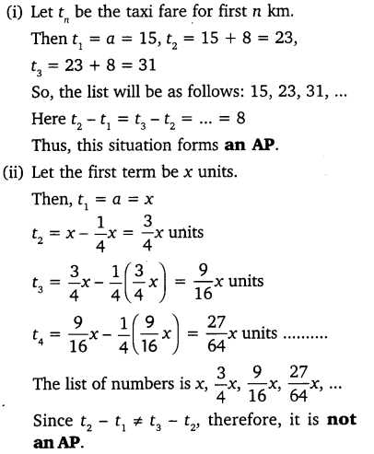

1. The amount of air present in a cylinder when a vacuum pump removes 14 of the air remaining in the cylinder at a time.



1. The cost of digging a well after every meter of digging, when it costs ₹ 150 for the first meter and rises by ₹ 50 for each subsequent meter.

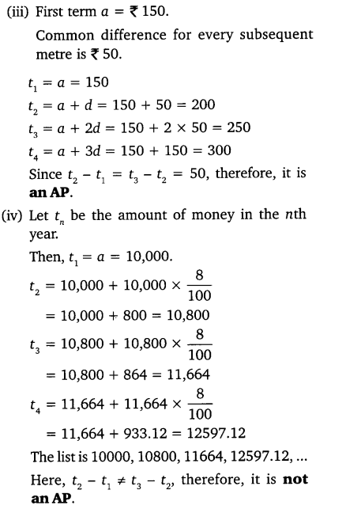

1. The amount of money in the account every year, when ₹ 10000 is deposited at compound interest at 8% per annum.



Question 2:

Write first four terms of the AP, when the first term a and the common difference d are given as follows:

1. a = 10, d = 10

Solution:

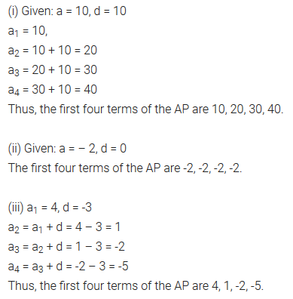

1. a = -2, d = 0

Solution:



1. a = 4, d = -3

Solution:



1. a = -1, d = ½

Solution:

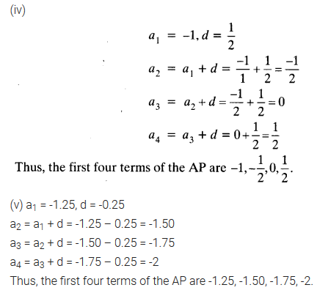

1. a = -1.25, d = -0.25

Solution:



Question 3:

For the following APs, write the first term and the common difference:  
(i) 3, 1, -1, -3, ……  
(ii) -5, -1, 3, 7, ……  
(iii) 1/3 , 5/3 , 9/3, 13/3 , ……..  
(iv) 0.6, 1.7, 2.8, 3.9, …….

Solution:

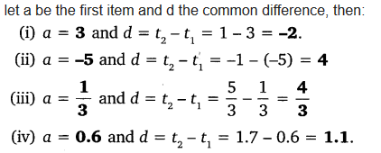

Question 4:

Which of the following are APs ? If they form an AP, find the common difference d and write three more terms.

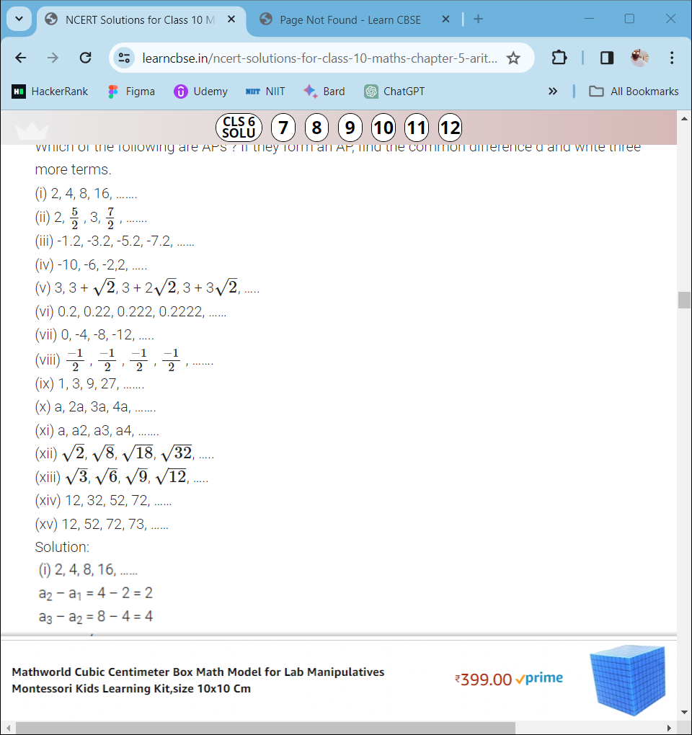

Solution:

